**Observation**

Inspection of the residential property was undertaken to which the following was noted:

***Entry Staircase***

1. Cracking and separation between the stairs leading to the entry door and the abutting wall was noted. **Images 2 – 4**
2. No evidence of flexible joint between the concrete stairs and abutting brick wall was noted to accommodate the differential movement between the two (2) different material namely concrete and brick.
3. As such, in the absence of such flexible sealant along the junction of concrete stairs and abutting brick wall, crack and separation as observed will propagate over time due to general building and differential thermal movements.

***Living Room***

*Eastern Wall*

1. Cracking within the Eastern wall and cornice propagating from the window opening facing the construction works was noted. **Image 6**
2. Evidence of previous attempts in repair of the plaster render crack propagating from the window opening along the aforementioned crack was noted suggesting the pre-existing origin of such crack.

*Southern Wall and Timber Flooring*

1. Visual evidence of uplift and cupping within the timber flooring was noted propagated about the middle of the living room in line with the southern window.
2. On the Southern window, a gap between the sliding panel and window framing was noted. **Images 7 & 8**
3. From the Insured’s provided advice, water ingress has occurred through the aforementioned gap within the window as a result of a blockage and overflowing of the eaves gutter above which has subsequently caused ingress of water into the living room resulting in water damage and cupping of the timber Living Room flooring as observed. **Image 9**
4. From observation, no evidence of cracking within the hardset plaster render around the window was noted. **Image 10**

***Kitchen***

1. Vertical cracking within the wall tiles and tile mortar joints about the south east and south western corner of the kitchen was noted. **Images 12 – 13**
2. About the south eastern corner of the kitchen, dislodgment of the wall tiles from the substrate was also noted.

***Bar Area***

1. Movement within the timber bar cabinetry panel and timber wall panel above was noted. **Image 15**

***Second Floor Bathroom***

1. Vertical cracking at the base of the toilet suite was noted. **Image 17**
2. Horizontal cracking within the ceramic tiles underneath the bathtub hob was noted. **Image 18**
3. Cracking within wall ceramic tiles underneath the window within the tile mortar joint at the wall corner along the southern wall alignment and was noted. **Images 19 & 20**
4. Evidence of previous attempt in sealing the vertical crack at the wall corner above the bathtub was noted suggesting the pre-existing origin of such crack.

***Second Floor Terrace***

1. Vertical cracking to the external brickwork about the north eastern corner of the bedroom adjacent to the sliding door was noted. **Image 21 – 23**
2. No visual evidence of vertical articulation joint within the brickwork was noted.
3. With reference to Australian Standard AS 4773.1 - *Masonry in Small Buildings*, articulation joints are to be used in masonry construction to reduce cracking or distress of masonry caused by contraction or expansion of the masonry units, or by footing movement or other structural movement.
4. AS 4773.1 specifies articulation joints shall be provided in masonry walls in accordance with the following locations:
5. Where openings more than 900 × 900 mm occur, at not more than 5 metres centres.
6. At a distance from all corners not greater than 4.5 metres and not less than 230 mm for veneer walls.
7. I confirm the abovementioned articulation joint requirements have not been completed within the external brickwork of this building.
8. In our opinion, the location, pattern and mechanism of the observed cracking within external brickwork are consistent with expansion of brickwork relative to omission of vertical articulation joint provisions within the building at time of original build.

***Second Floor Hallway***

1. Cracking within the Hallway ceiling plasterboard lining was noted propagating along the plasterboard sheet butt joint and at the change of direction in plasterboard sheet layout. **Image 24**
2. I noted that no provision for any expansion joints within the ceiling lining throughout the dwelling have been installed.
3. With reference to plasterboard lining installation guidance, expansion (control) joints within ceiling lining should be installed at maximum 12m intervals and at the change of direction in plasterboard sheet layout to accommodate structural movement or alterations in ambient conditions[1].
4. As such, in our opinion, this observed damage and similar cracks throughout the dwelling is related to general building movement over time in the absence of expansion joints.

### Discussion: Ground Vibration Analysis & Damage

1. When considering possibilities of vibrations causing damage on buildings and structures, differentiation between 'air-borne' and 'ground' vibrations is critical in assessing causation subject to the following qualifications:
   1. Air-borne vibrations are those that travel through the air as a consequence of the operation of machinery and other equipment. Whilst these vibrations often cause the rattling of windows and tea cups on shelves, and distress and discomfort to nearby residents, they are typically of high-frequency and low energy.
   2. Ground vibrations are those that travel through the ground as a consequence of heavy equipment [e.g. a large road roller, rock hammers, etc. traversing and *I* or impacting the ground.
   3. As air-borne vibrations are typically of low energy and high-frequency, they seldom cause building damage; by contrast, because ground vibrations can be of high-energy and low-frequency, ground vibrations can cause damage to buildings if the vibration source is sufficiently close to the building, and of sufficient energy.
2. In view of the above, any damage caused by vibrations from construction equipment, earth tremors & mining has a particular 'signature', and is usually apparent **immediately after the event.**
3. In relation to the particular 'signature' of vibration damage, the following are expected:
   1. The most usual form of vibration damage is diagonal cracking and surface hairline cracks within masonry walls and plaster at stress concentrations around openings and corners as a result of the 'stretching' of the building structure during the ground vibration.
   2. Any 'zig zag' cracks in masonry walls along mortar joints, or tapered gaps at wall joints, are typically related to a loss of structural support underneath a footing i.e. foundation settlement rather than ground vibrations.
   3. Any damage observed to a building weeks *I* months after a vibration event should not be attributed to ground vibrations because vibration damage is relatively 'immediate'.
4. In assessing the Insured’s claim, we have adopted an objective approach and referred to scientific and engineering principles in this report.
5. Without actual vibration monitoring results, this report aims to assess the possibility of claimed vibration damage to the subject building against a series of conditions, parameters and circumstances of this site using relevant vibration standards and guidelines.
6. In general, sources of vibration include blasting, demolition, piling, ground treatments (e.g. compaction), construction equipment, tunnelling, road and rail traffic and industrial machinery.
7. In determining the acceptable ground vibration level for the subject historical building, we refer to Queensland Government Transport & Main Roads May 2013 Technical Note 3 – Measurement of Ground Vibrations and Air blasts, **Table 1.**

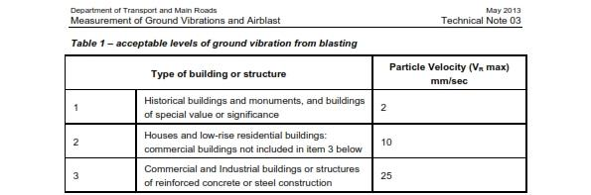

**Table 1– Acceptable Levels of Ground Vibration from Blasting Table 1*.***

1. From **Table 1,** the subject property falls within category 2 in this case with an acceptable level of ground vibration of 10**mm/sec** Particle Velocity (PPV) to cause any superficial damage.
2. Although information on the type of machinery used for construction works fronting the subject property has not been provided, we acknowledge that the works involves construction of a track slab for the proposed Light Rail.
3. For this process, excavators, jackhammers, compactors and other vibrating machinery are typically used.
4. Typical heavy machinery consists of the following ground vibration level PPV indicated in **Table 2**, excerpted from a Roads & Maritime Service Project Noise, Construction and Vibration Assessment Plan for Narellan Road Upgrade completed by Renzo Tonin & Associates Pty Ltd in 2013.

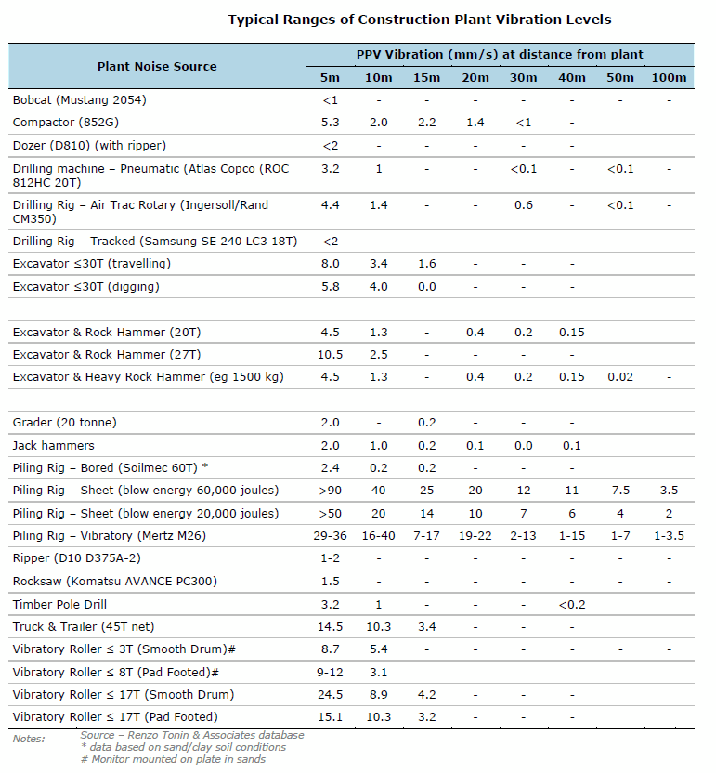

**Table 2– Typical Heavy Machineries Ground Vibration Level**

1. From the aerial view in ***Figure 1***, the nearest point of the Insured’s dwelling is approximately 10m away from the subject construction zone.
2. With reference to **Table 2**, the expected ground vibration levels for aforementioned machineries at a distance of approximately 10m away from the source of vibration **will not reach** the ground vibration level of **10mm/sec** PPV to cause vibrational damage within the subject dwelling.
3. With reference to **Table 2** and the resulting ground-borne vibration relative to the distance from the source, the observed damage within the Insured’s dwelling **is not consistent with ground borne vibrational damage caused as a result of the Sydney Light Rail (SLR) construction works along Anzac Parade.**

### Review of Dilapidation Report and Discussions on the Cause of Observed Damage

***Entry Staircase***

1. From review of the photos within the dilapidation report related to the entry staircase, the quality of photos is not suitable to assess the presence of the observed crack and therefore such photos are disregarded in our assessment.
2. From our vibrational analysis and assessment, the observed damage within entry staircase falls well outside of the influence zone of the ground-borne vibrations from SLR construction works.
3. In our opinion, the observed damage is pre-existing and is a result of general building and differential thermal movements over time in the absence of adequate flexible sealant between the stairs and wall.
4. As such, the observed damage within entry staircase is not related to the alleged ground-borne vibration from SLR construction works.

***Living Room***

1. From review of the photos within the dilapidation report related to the living room, the quality of photos is not suitable to assess the presence of the observed crack and therefore such photos are disregarded in our assessment.
2. From our vibrational analysis and assessment, the observed damage within living room falls well outside of the influence zone of the ground-borne vibrations from SLR construction works.
3. In our opinion, the observed cracking is pre-existing relative to evidence of previous repairs and is not related to the alleged ground-borne vibration from SLR construction works.
4. In the absence of visual evidence of cracking around the southern window to suggest that the observed gap and movement of the window framing was a result of vibrational activity, in our opinion, the movement and gap within the window sliding panel is not related to the alleged ground-borne vibration from SLR construction works.
5. On this basis, in our opinion, the cause of water ingress is a result of blockage of the eaves gutter above the window resulting in water damage to the timber flooring in a one-off incident and is unrelated to vibrational activity.

***Kitchen***

1. From review of the photos within the dilapidation report related to the kitchen, the quality of photos is not suitable to assess the presence of the observed crack and therefore such photos are disregarded in our assessment.
2. From our vibrational analysis and assessment, the observed damage within kitchen falls well outside of the influence zone of the ground-borne vibrations from SLR construction works.
3. In our opinion, the observed pattern of damage is not consistent with vibrational damage but rather, the cracking and damage within the tiles and mortar joints are consistent with general building movement over time.

***Bar Area***

1. From review of the photos within the dilapidation report related to the bar area, movement within the bar joinery panel was noted and therefore such movement is pre-existing in origin and unrelated to construction activities – Refer to **Figure 2**.



**Figure 2 – Imagery Excerpted from the Dilapidation Report (Photo 182)**

1. From our vibrational analysis and assessment, the observed damage within bar area falls well outside of the influence zone of the ground-borne vibrations from SLR construction works.
2. From our review of dilapidation report and our vibrational assessment, the observed damage within bar area is not related to the alleged ground-borne vibration from SLR construction works.

***Second Floor Bathroom***

1. From our vibrational analysis and assessment, the observed damage within the subject bathroom falls well outside of the influence zone of the ground-borne vibrations from SLR construction works.
2. In our opinion, the pattern and mechanism of observed damage within bathroom is not consistent with vibrational damage but is rather related to general building movement.
3. In addition, evidence of previous attempt in sealing the vertical crack at the wall corner above the bathtub was noted suggesting the pre-existing origin of such crack.
4. As such, the observed damage within bathroom is not related to the alleged ground-borne vibration from SLR construction works.

***Second Floor Terrace***

1. From our vibrational analysis and assessment, the observed damage within the subject terrace falls well outside of the influence zone of the ground-borne vibrations from SLR construction works.
2. In our opinion, the location, pattern and mechanism of the observed cracking within external brickwork are consistent with expansion of brickwork relative to omission of vertical articulation joint provisions within the building at time of original build.
3. As such, the observed damage within terrace is not related to the alleged ground-borne vibration from SLR construction works.

***Second Floor Hallway***

1. From our vibrational analysis and assessment, the observed damage within the subject hallway falls well outside of the influence zone of the ground-borne vibrations from SLR construction works.
2. In our opinion, this observed damage and similar cracks throughout the dwelling is related to general building movement over time in the absence of expansion joints.
3. As such, the observed damage within hallway is not related to the alleged ground-borne vibration from SLR construction works.

**Discussion**

NA

**Conclusion**

From our vibrational analysis and assessment, the observed damage throughout the subject dwelling falls well outside of the influence zone of the ground-borne vibrations from SLR construction works.

In our opinion, all presented damage by the Insured as detailed within the body of this report is not related to the alleged ground-borne vibration from SLR construction works.

On such basis, we consider the observed damage within the Insured’s dwelling to be **inconsistent with ground borne vibrational damage related to the construction works along Anzac Parade.**

We note the Insured’s testimony about feeling vibrations and window shaking during the course of the construction works; however, the applied engineering and vibrational data **does not support** a claim for resulting damage to the building as asserted by the Insured.

In our opinion, the observed crack damage throughout the dwelling is attributable to general building and differential thermal movements occurred over an extended period of time in years.

In our opinion, all presented damage by the Insured is a due to general wear & tear and deterioration relating to maintenance and upkeep.

1. Boral’s “Plasterboard Installation Manual” – [www.boral.com.au](http://www.boral.com.au)